**Mussel and Scallop Measuring and Tagging Protocol**

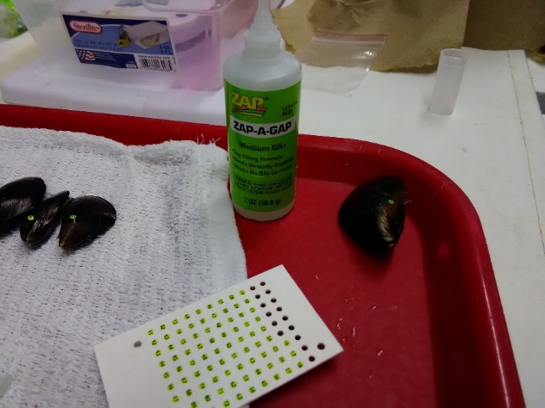**Padilla-Gamiño Lab**  
School of Aquatic and Fishery Sciences  
University of Washington

**Materials:**

1. **Cleaning** 
   * Wire Scrub Brushes
   * Stiff bristled brushes
   * Rags
   * Paper Towels
   * Knives
2. **Measuring & Tagging**
   * Calipers
   * Scale (0.001 significant figures)
   * Bee Tags

<https://www.beeworks.com/catalog/index.php?main_page=product_info&products_id=125>

* + Zap-a-gap glue (4 2oz bottles)

<https://www.amazon.com/Pacer-Technology-Zap-Zap-Adhesives/dp/B00SXJJ2OU>

* + Insta-set accelerator (4 bottles)

<https://www.amazon.com/Bob-Smith-151-Insta-Set-Accelerator/dp/B0000DD1QR>

* + Tweezers
  + Lunch Trays (at Taylor)
  + Clothes Pins (at Taylor)

**Procedure:**

1. Thoroughly clean mussels and scallops removing all epibionts including tubeworms and barnacles.

* Use either stiff bristled brushes or wire brushes.
* Note: Stiff bristled seemed to work for young scallops; with larger adults that have more epibionts, wire brushes can be used (they can be hard on smaller ones in my opinion)
* Often barnacles and tubeworms are difficult to remove so you may need a knife.

1. Set up a station with a scale (or two) and calipers to weigh and measure the scallops including somewhere to record the measurements. Be sure to have plenty of rags and paper towels.
2. Set up another station to tag the mussels with zap-a-gap, bee tags, and tweezers, and an area to spray insta-set accelerator.

* The insta-set accelerator should be used near a well-ventilated area, and limit the amount of trays that the insta-set accelerator is used on.

1. Scallops should be pinned shut with a clothespin to prevent water loss and lined up on a lunch tray.

* Keeping in mind it is important to get them back into the water as soon as possible, line as many as you can tag, measure, and return to the water efficiently.

1. Carefully and quickly poke bee tags out of the paper where they are secured to line them up on the tray. (Only the amount you NEED/ the amount of scallops you lined up)
2. Dry the outside of the shell with paper towels and dot the glue slightly towards the right near the first visible “ring”/shell layer of the shell
3. Use the tweezers to handle the bee tags and make sure dots are embedded with glue. You may add more glue if necessary.

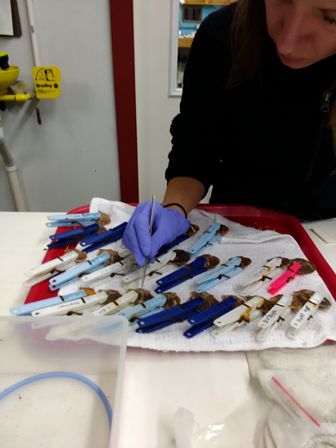 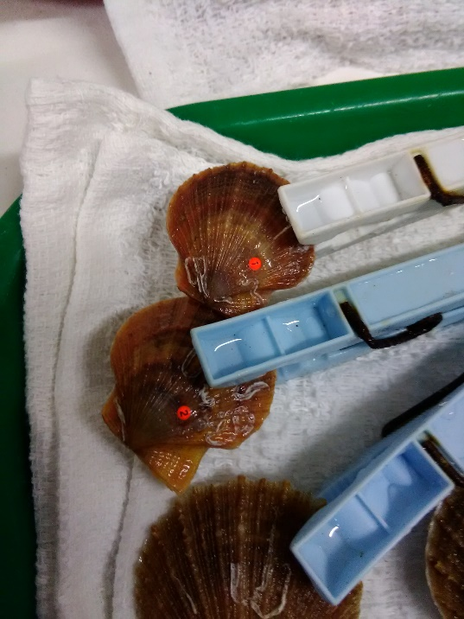

1. Move scallops to a “spray tray” to quickly spray them with insta-set accelerator.

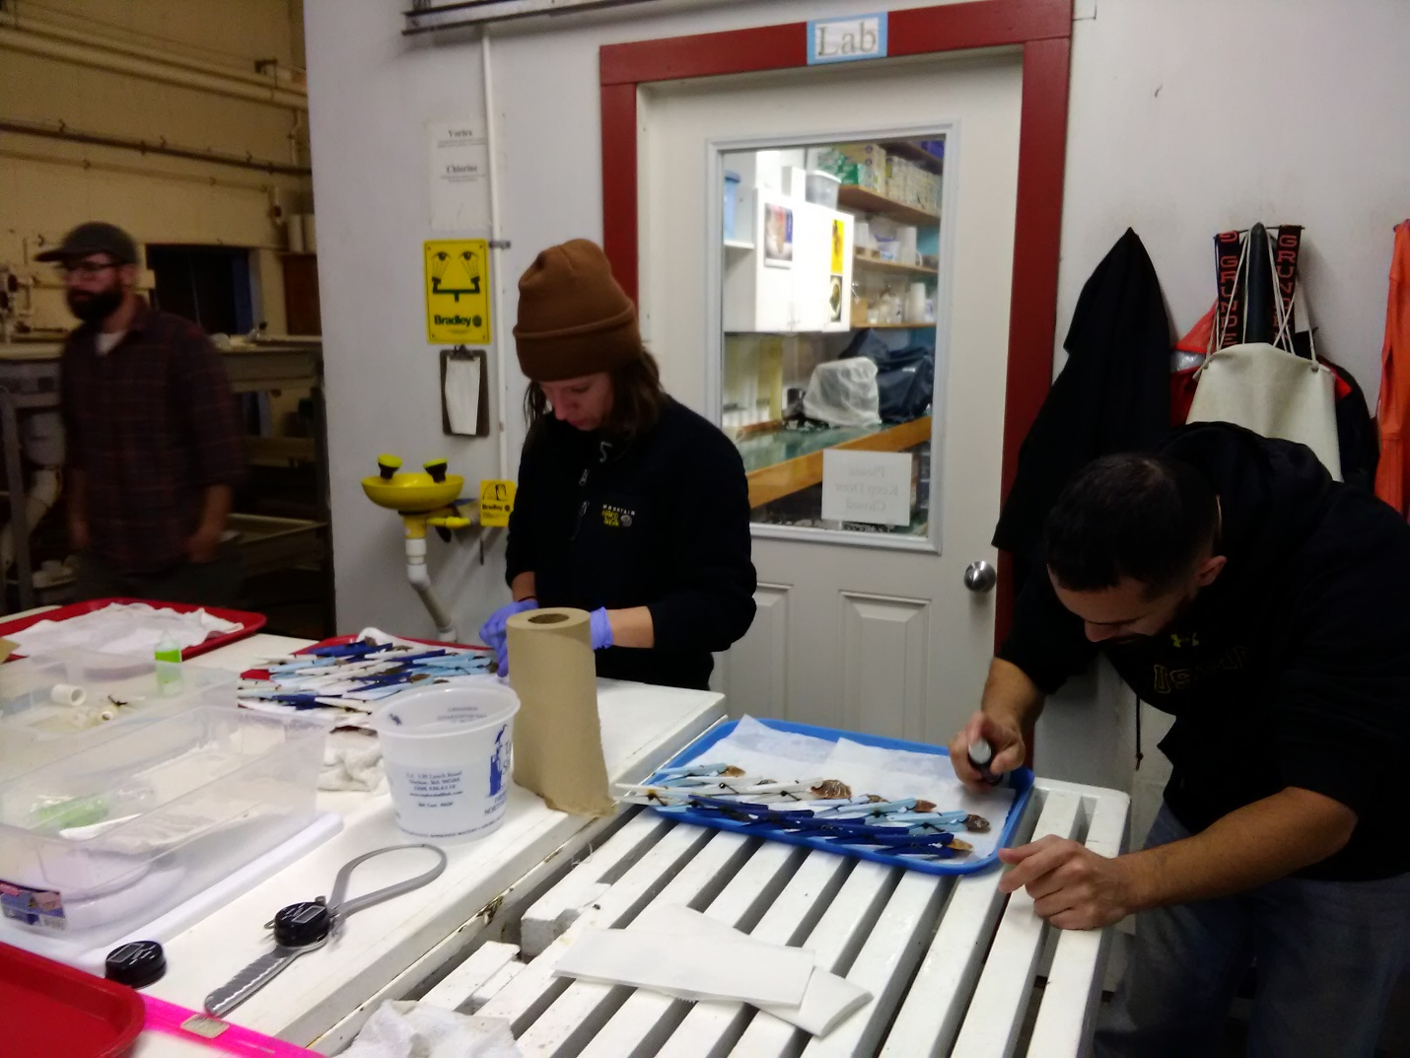

1. Wait a short period to ensure it is dry then dip the scallops in water to remove excess chemicals before they are returned to the tanks.
2. Measure and record the length and width of the scallops.
3. Weigh the scallops
4. Return scallops to water.
5. The same procedure was used for mussel, however the shells of the mussels were not pinned shut.

